**Kamala Education Society’s**

Pratibha Institute of Business Management

**Chinchwad, Pune-411019**

## 2022-2023

## SYNOPSIS REPORT ON

**“Medical Reports - Online Consultation”**

**BY**

## DIPESH PATIL

**Course: MCA (1st year ,2st semester)**

## Guide Name:

**Prof. Kalyansing Patil**

1. **Introduction to project:**

Medical Reports - Online Consultation is a web application Developed in PHP. It helps patients to get opinion on their medical reports (ECG, Blood Test).

Medical Reports - Online Consultation saves the users time and money. They need not to reach doctors for normal report consultation.

Medical Reports - Online Consultation provides reports in simple language which users can easily understand.

**1.1. Objective: -**

* The main objective of the Medical Reports - Online Consultation is to provide consultation on medical reports in low cost and save the time of patients.
* Patients can easily upload reports on portal. Simple and Clean user-friendly User Interface.
* It Manages Patient information, Medical Reports, Doctors information and Login credentials securely.
* The project is built for three users Admin, Patients, Doctors/Specialists. All users have specific access as per their need.

**1.2 Existing System**: -

Currently patients need to take an appointment with doctor to get consultation on medical reports. This is time-consuming and costly.

**Need For the System:**

* To change the offline process of medical consultation which is time consuming and costly.
* This system provides user friendly interface and better consultation with simple consultation report in short time.
* There are many registers be maintained.

**Advantages: -**

1. No need of computer expert person to operate the system.
2. Saves time and energy.

**2.Scope of work**

* Medical Reports - Online Consultation is web-based applications which users can easily access in any web browser using URL.
* Users can easily create an account and upload medical reports (ECG, Blood Test). After specialist’s review users can download report in pdf format.
* Doctors can easily monitor the reports received and after review the can create a simple report for user in doctor’s portal.
* Admin can monitor the Users, Doctors, Reports, and Transactions in admin portal.

**2.3.Goals Of Proposed System:-**

* **Proper Data Storage: -**The data will be stored properly in the data store, which helps in the quick retrieval of information.
* **Accuracy: -**The level of accuracy in the given system is higher. All the entries would be done correctly and it ensures that whatever information coming from sources is accurate.
* **Reliability: -**The reliability of the proposed system is higher due to the above stated reasons. The main reason of increased reliability is proper storage of the entered information.
* **Immediate Retrieval of Information: -**The proper data storage made possible of immediate data retrieval. User of the system can get any type of information he wants just by specifying Bill No.
* **Immediate Data Storage: -**In manual system there are many problems with large data storage, but this provides the faster data storage with the validation for the redundancy.
* **Easy to Operate: -**The system is very easy to operate as it is developed in the user-friendly language and with proper labels and hints.

**System Analysis and Design**

**3.1 ER Diagram**

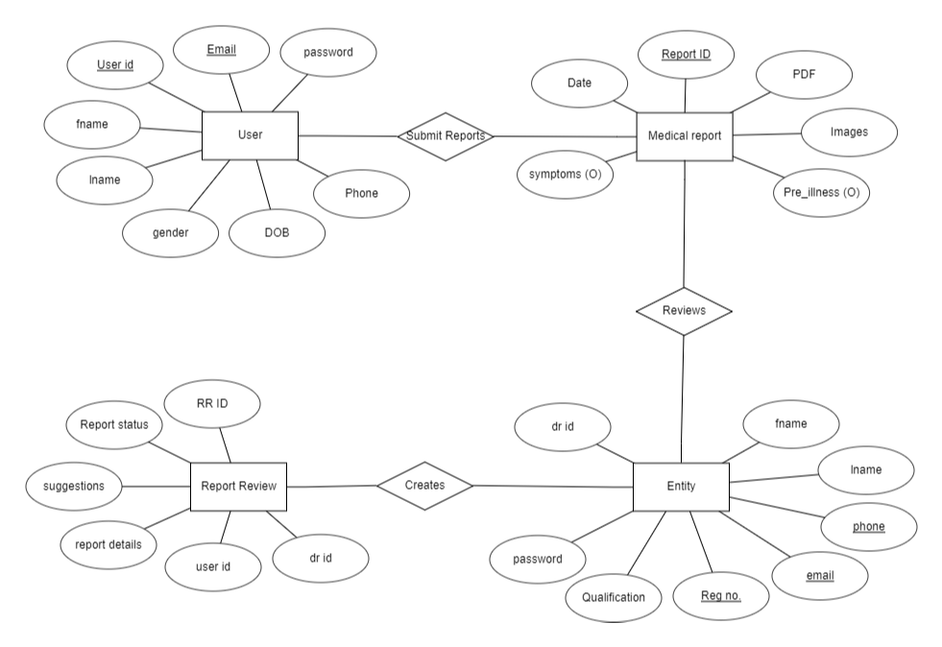

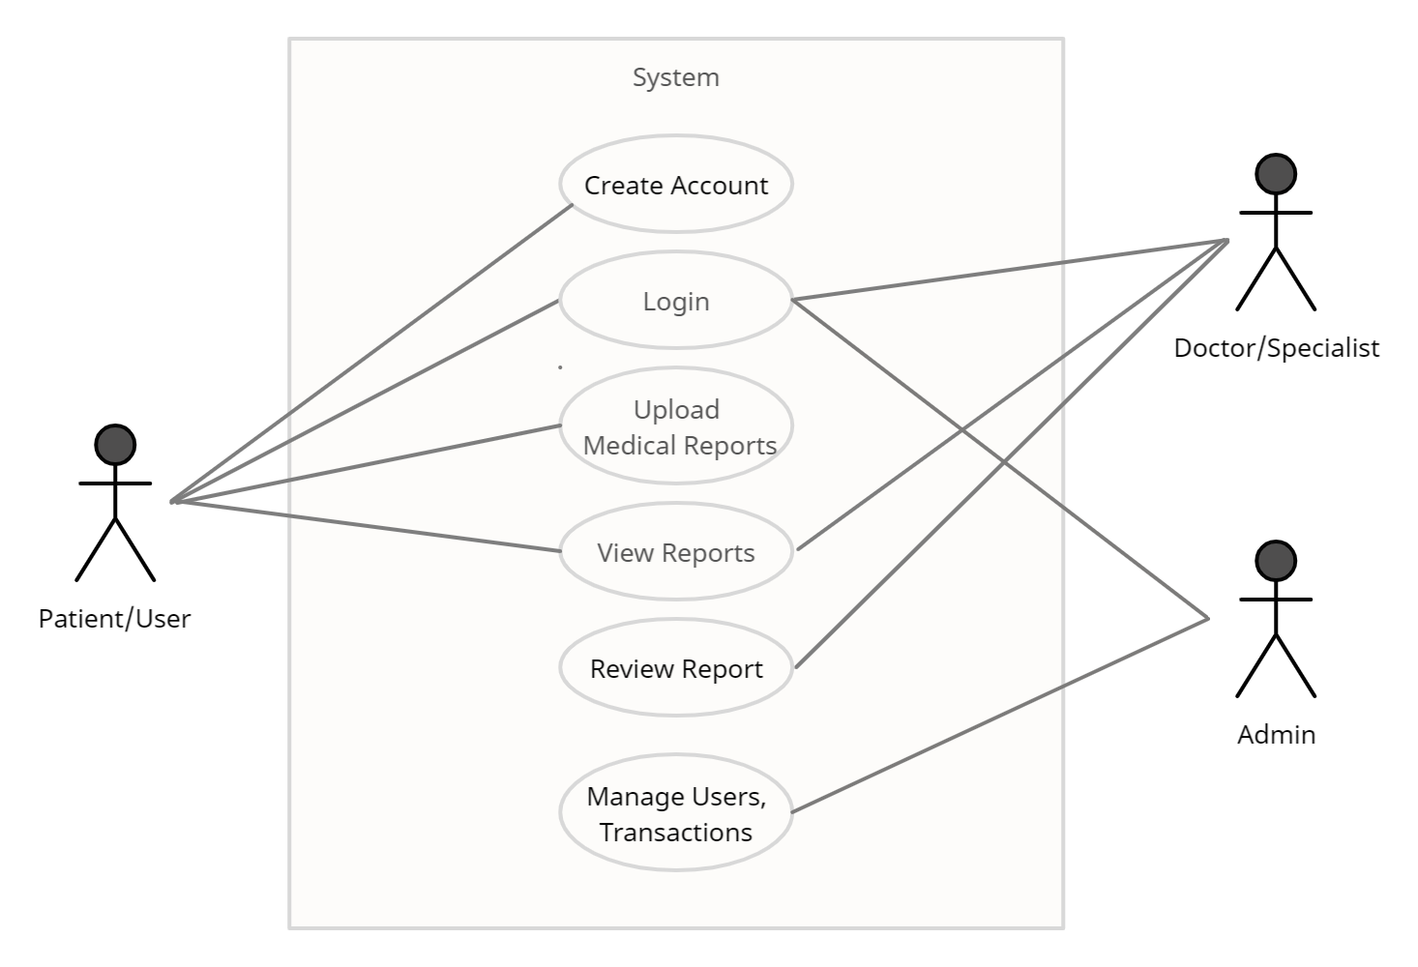**3.2 Use Case Diagram**

**4.Technical Solution**

**3.1.Technologies Used Are:-**

This project is a desktop application which is developed using java development software and MySQL as a backend for data storage.

* Database Design (MySQL Server (Xampp))
* Form Design (HTML, CSS)
* Coding (PHP)

**3.2.Project Requirements: -**

**Hardware Requirements**

|  |  |  |
| --- | --- | --- |
| Processor | Ram | Disk Space |
| Pentium-2,3,4 or any  Higher version | 2 GB or Higher | 512 Mb or More |

**Software Requirements**

|  |  |
| --- | --- |
| Operating System | Database |
| Windows 10 & Above | MySQL Server (Xampp) |
| Any version of Linux | MySQL |

Project Guide Name:

Prof. Kalyansing Patil

Signature